AWS IAM Single User Creation and Giving Permissions
Objectives
• To understand AWS Identity and Access Management (IAM) and its role in controlling access to AWS resources.
• To create a single IAM user in the AWS Management Console for secure access instead of using the root account.
• To configure console login credentials by assigning a username and custom password for the IAM user.
• To assign permissions to the IAM user using AWS managed policies.
• To grant Amazon S3 access by attaching the AmazonS3FullAccess policy to the user.
• To verify user authentication by signing in through the IAM user login page.
• To observe permission restrictions and understand how AWS limits access to only the services allowed by the attached policy

1 | Open the IAM Dashboard

- Log in to the AWS Management Console.
- Navigate to IAM (Identity and Access Management).
- The IAM Dashboard appears showing security recommendations.
- On the left sidebar under Access Management, click Users.
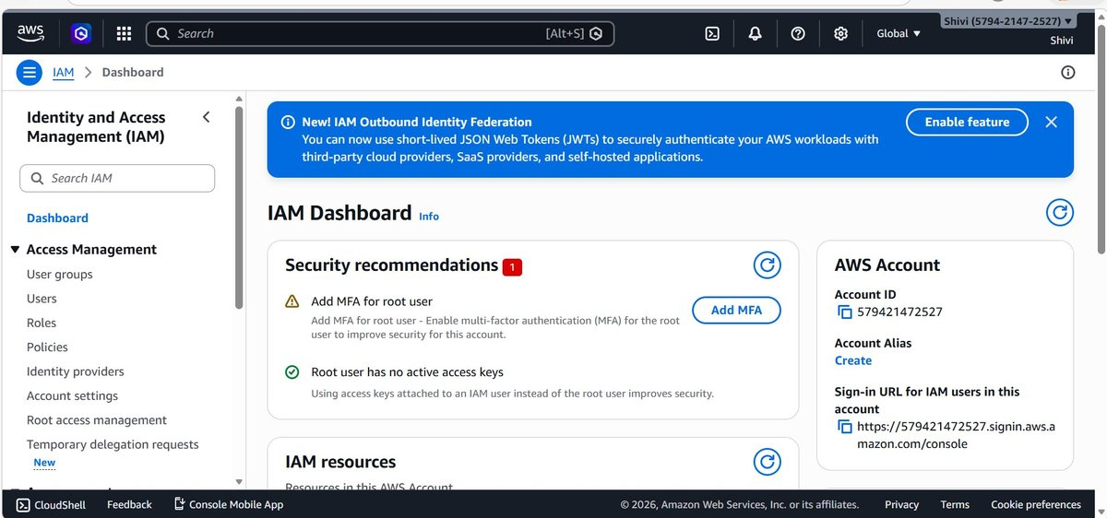

2 | View the Users List

- The Users page opens.
- The page shows Users (0), meaning no IAM users exist yet.
- An empty table appears with the message “No resources to display.”
- Click the Create user button in the top-right corner.

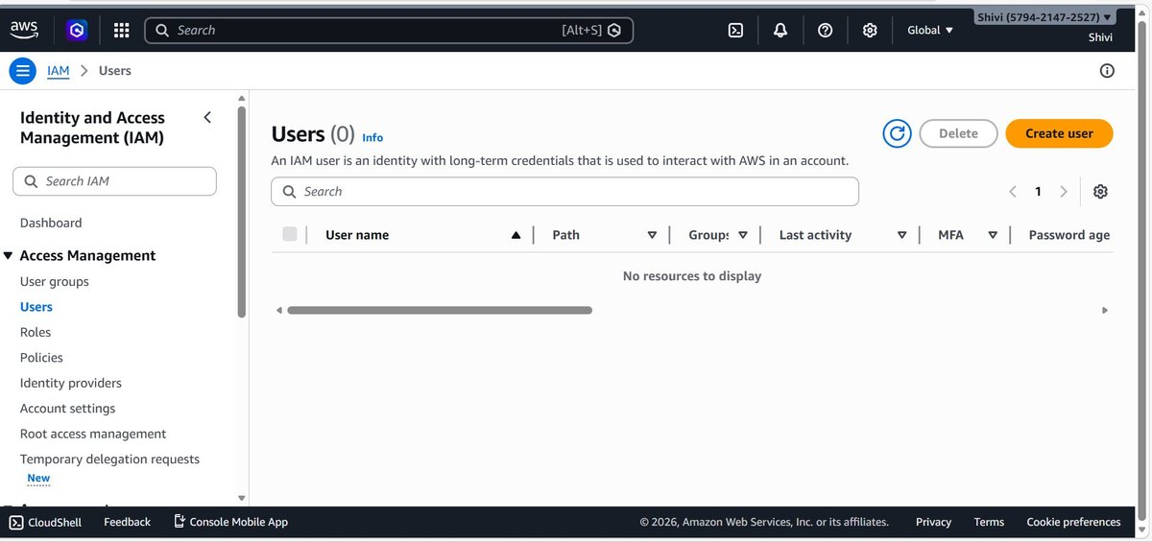

3 | Specify User Details

- The Create user wizard opens at Specify user details.
- Enter the User name
- Enable Provide user access to the AWS Management Console.
- Select Custom password and enter a password.

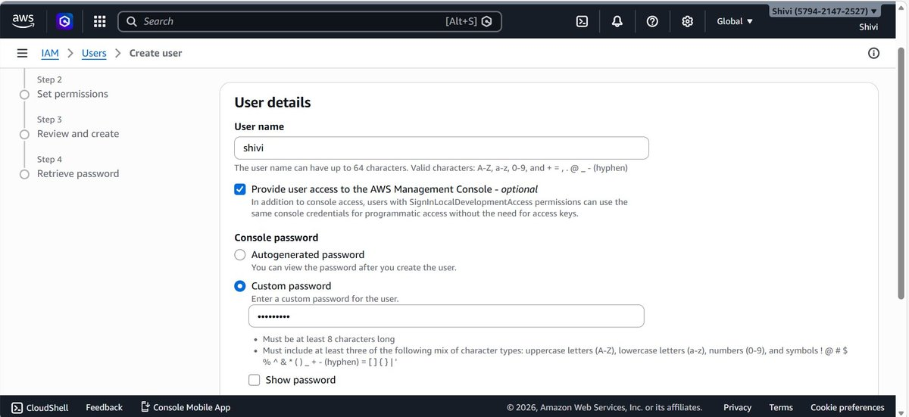

4 | Configure Password Settings

- Scroll down to view additional password options.
- Ensure Custom password is selected.
- Leave Users must create a new password at next sign-in unchecked.
- Click Next to continue.

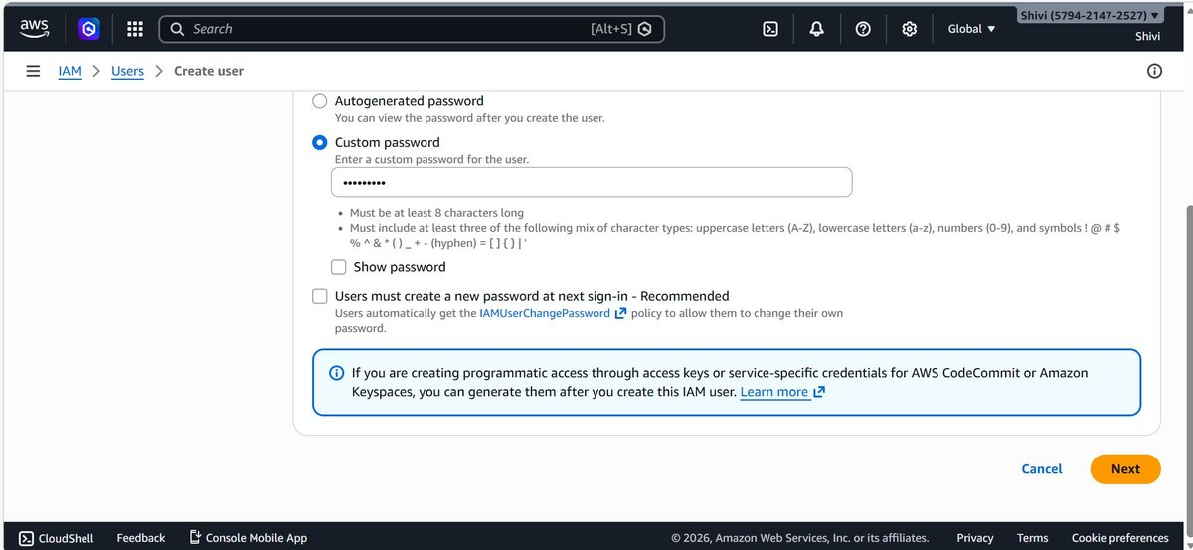

5 | Set Permissions for the User

- The wizard moves to Set permissions.
- Select Attach policies directly.
- In the search bar, type S3.
- From the results, select AmazonS3FullAccess.

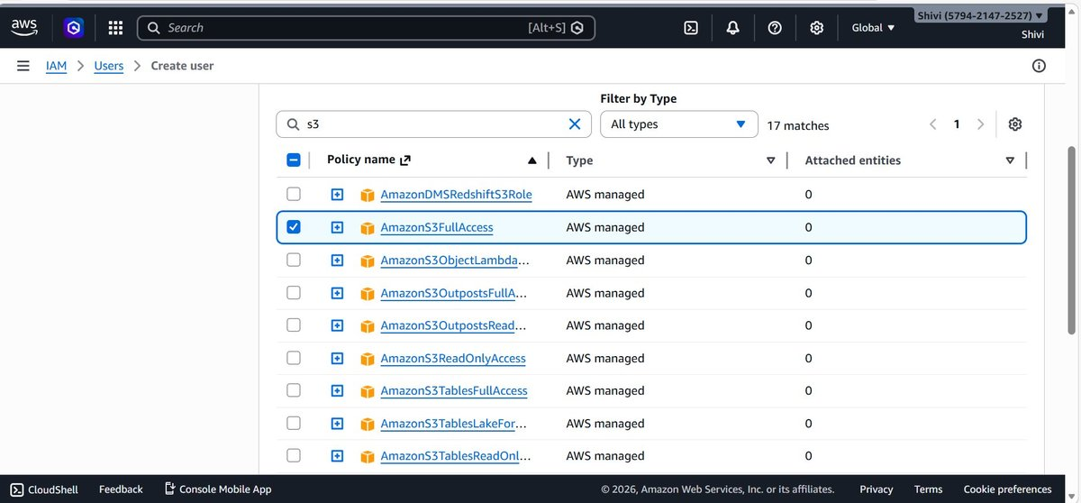

6 | Review User Configuration

- The Review and create page appears.
- Confirm the following details:
  - Username
  - Password type: Custom password
  - Policy attached: AmazonS3FullAccess
- After verifying everything, click Create user.

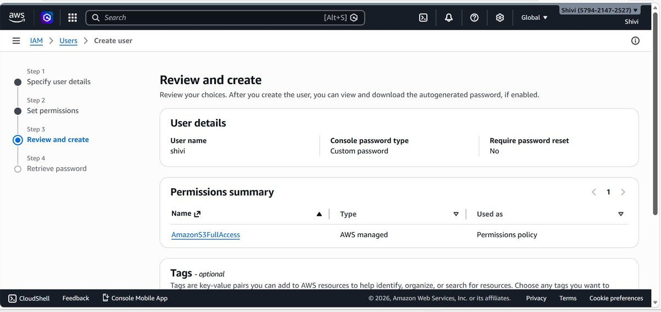

7 | Retrieve Login Credentials

- The system shows Retrieve password.
- The following information is displayed:
  - Console sign-in URL
  - IAM username
  - Password

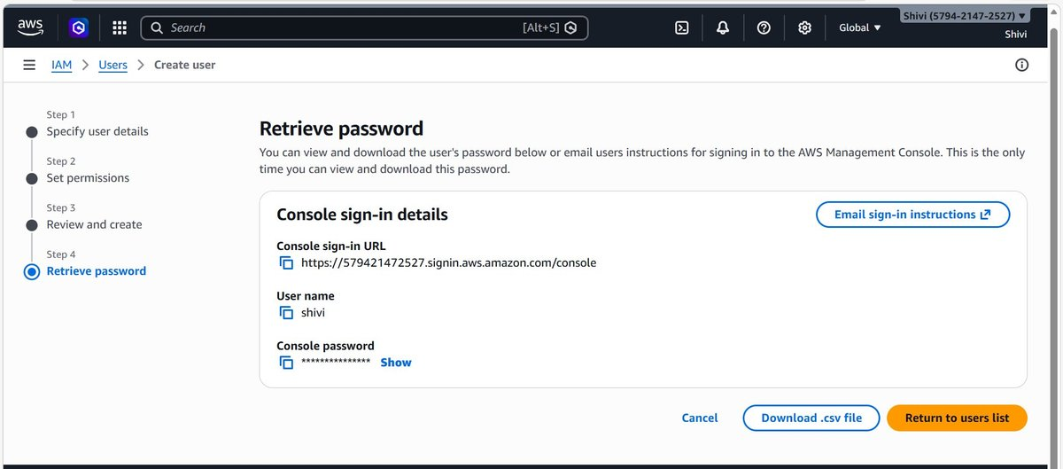

8 | Open the IAM User Sign-In Page

- Open the IAM sign-in URL provided.
- The login page appears.
- Enter:
  - Account ID
  - IAM username
  - Password
- Click Sign in.

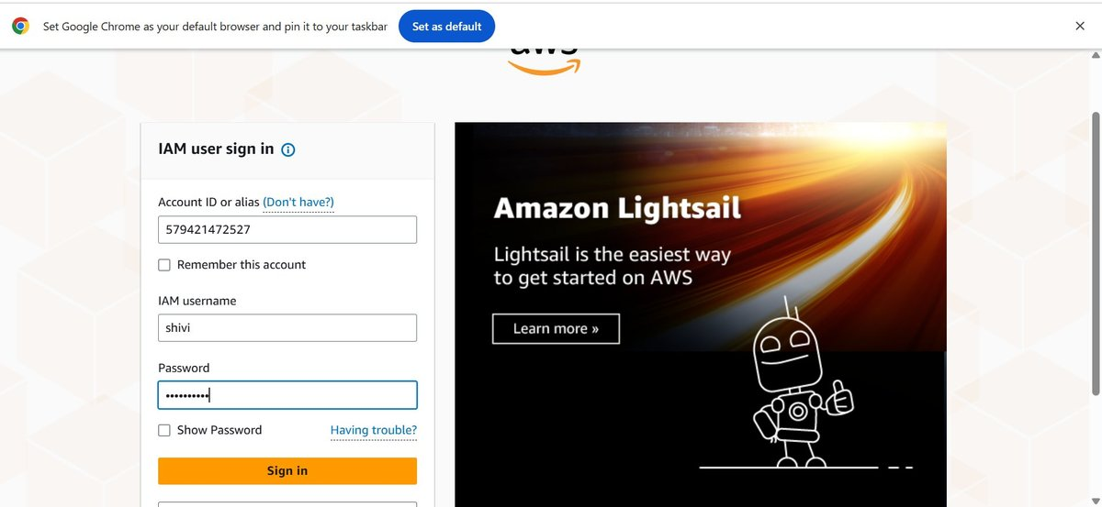

9 | Verify IAM User Login

- After logging in, the AWS Management Console opens.
- The top-right corner shows the logged-in IAM user name.
- Some services like Billing or AWS Health may show Access Denied because only AmazonS3FullAccess permission was given.
- This confirms that the user has access only to Amazon S3.

